# Exercises: Objects and Classes

Problems for exercises and homework for the [“Programming Fundamentals” course @ SoftUni](https://softuni.bg/courses/programming-fundamentals).

You can check your solutions here: <https://judge.softuni.bg/Contests/175/Objects-and-Classes-Lab>

## Day of Week

You are given a **date** in format **day-month-year**. Calculate and print the day of week in **English**.

### Examples

|  |  |
| --- | --- |
| **Input** | **Output** |
| 18-04-2016 | Monday |
| 27-11-1996 | Wednesday |

### Hints

* **Read the date as string** from the Console
* Use the method [DateTime.ParseExact(string date, format, provider)](https://msdn.microsoft.com/en-us/library/w2sa9yss(v=vs.110).aspx) with format **“dd-MM-yyyy”** to create object of type **DateTime**
* To the newly created DateTime object has property [DayOfWeek](https://msdn.microsoft.com/en-us/library/system.datetime.dayofweek(v=vs.110).aspx). Just print it’s value to the console

## Randomize Words

You are given a **list of words in one line**. **Randomize their order** and print each word at a separate line.

### Examples

|  |  |  |
| --- | --- | --- |
| **Input** | **Output** | **Comments** |
| Welcome to SoftUni and have fun learining programming | learining  Welcome  SoftUni  and  fun  programming  have  to | The order of the words in the output will be different in every execution of the program |

### Hints

* **Split** the input string by (space) and create **array of words**
* Create object of type **Random**
* Make a **for-loop** that loops from **0** to **words.Length**
* On each iteration **get 1 random** number **in range [0, words.Length)** (you can use the method of the your **Random** object - [.Next(minValue, maxValue)](https://msdn.microsoft.com/en-us/library/2dx6wyd4(v=vs.110).aspx)) and **swap the word** at current position on the iteration with the word on on the random position you got
* Print each word in the array on new line

## Big Factorial

Calculate n! (n factorial) for very big n (e.g. 1000)

### Examples

|  |  |
| --- | --- |
| **Input** | **Output** |
| 5 | 120 |
| 50 | 3041409320171337804361260816606476884437764156896051200000000000 |

### Hints

Use the class BigIntegerfrom the built-in .NET library System.Numerics.dll.

1. First add reference to System.Numerics.dll.

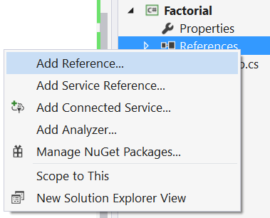

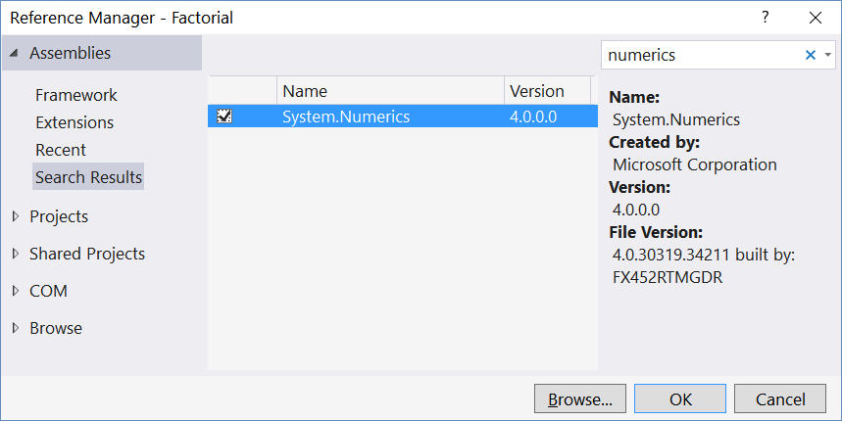

1. Import the namespace “System.Numerics”:



1. Use the type BigInteger instead of long or decimal to keep the factorial value:

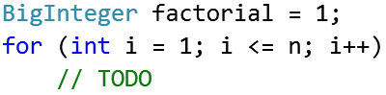

## Distance between Points

Write a method to calculate the distance between two points **p1** {**x1**, **y1**} and **p2** {**x2**, **y2**}. Write a program to read **two points** (given as two integers) and print the **Euclidean distance** between them.

### Examples

|  |  |
| --- | --- |
| **Input** | **Output** |
| 3 4  6 8 | 5.000 |
| 3 4  5 4 | 2.000 |
| 8 -2  -1 5 | 11.402 |

### Hints

* Create **class Point** with properties **X** and **Y**
* Write a method **CalcDistance(Point p1, Point p2)** that returns the distance between the given points
* Use [this formula](http://www.cut-the-knot.org/pythagoras/DistanceFormula.shtml) to find the distance between two points
* You can use [Math.Sqrt(number)](https://msdn.microsoft.com/en-us/library/system.math.sqrt(v=vs.90).aspx) method to help you with the calculations

## Closest Two Points

Write a program to read **n** points and print the **closest two** of them.

### Examples

|  |  |
| --- | --- |
| **Input** | **Output** |
| 4  3 4  6 8  2 5  -1 3 | 1.414  (3, 4)  (2, 5) |
| 3  12 -30  6 18  6 18 | 0.000  (6, 18)  (6, 18) |

### Hints

* Use the **class** **Point** you created in the previous task
* Create an array **Point[] points** that will keep all points
* Create a method **Point[] FindClosestPoints(Point[] points)** that will check distance between every 2 points in the array of points and returns the 2 closes points in a new array
* Print the **closest distance** and the **coordinates** of the 2 closes points

## Rectangle Position

Write a program to **read two rectangles** {left, top, width, height} and print whether the first is inside the second.

### Examples

|  |  |
| --- | --- |
| **Input** | **Output** |
| 4 -3 6 4  2 -3 10 6 | Inside |
| 2 -3 10 6  4 -5 6 10 | Not inside |

## Sales Report

Write a class **Sale** holding the following data:

* **Town**, **product**, **price**, **quantity**

Read a **list of sales** and print the **total sales by town**.

### Examples

|  |  |
| --- | --- |
| **Input** | **Output** |
| 5  Sofia beer 1.20 160  Varna chocolate 2.35 86  Sofia coffee 0.40 853  Varna apple 0.86 75.44  Plovdiv beer 1.10 88 | Plovdiv -> 96.80  Sofia -> 533.20  Varna -> 266.98 |

## Count Working Days

Write a program that **reads two dates** in format **dd-MM-yyyy** and prints the **number of working days** between these two dates **inclusive**. Consider that **official holidays** are New Year Eve (**1 Jan**), Liberation Day (**3 March**), Worker’s day (**1 May**), Saint George’s Day (**6 May**), Saints Cyril and Methodius Day (**24 May**), Unification Day (**6 Sept**), Independence Day (**22 Sept**), National Awakening Day (**1 Nov**), Christmas (**24, 25, 26 Dec**). Consider also **leap years** have 1 extra day.

### Examples

|  |  |
| --- | --- |
| **Input** | **Output** |
| 11-04-2016  14-04-2016 | 4 |
| 11-04-2016  22-04-2016 | 10 |
| 20-12-2015  31-12-2015 | 7 |